WEEK 2

1. Write a lex program to check whether input is digit or not

%{

#include<stdio.h>

#include<stdlib.h>

%}

%%

^[0-9]\* printf("digit");

^[^0-9]|[0-9]\*[a-zA-Z] printf("not a digit");

.;

%%

int yywrap()

{

}

int main()

{

yylex();

return 0;

}

OUTPUT

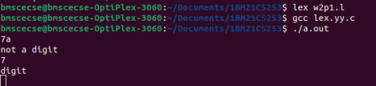

2. Write a lex program to check whether the given number is even or odd. %{

#include<stdio.h>

int i;

%}

%%

[0-9]+ {i=atoi(yytext);

if(i%2==0)

printf("Even");

else

printf("Odd");}

%%

int yywrap(){}

int main()

{

yylex();

return 0;

}

OUTPUT

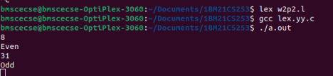

3. Write a lex program to check whether a number is Prime or not.

%{

#include<stdio.h>

#include<stdlib.h>

int flag,c,j;

%}

%%

[0-9]+ {c=atoi(yytext);

if(c==2)

{

printf("\n Prime number");

}

else if(c==0 || c==1)

{

printf("\n Not a Prime number");

}

else

{

for(j=2;j<c;j++)

{

if(c%j==0)

flag=1;

}

if(flag==1)

printf("\n Not a prime number");

else if(flag==0)

printf("\n Prime number");

}

}

%%

int yywrap()

{

}

int main()

{

yylex();

return 0;

}

OUTPUT

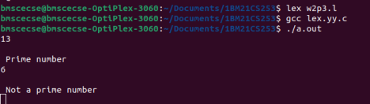

4. Write a lex program to recognize a) identifiers

b) keyword-int and float

c) anything else as invalid tokens.

%{

#include<stdio.h>

%}

alpha[a-zA-Z]

digit[0-9]

%%

(float|int) {printf("\nkeyword");}

{alpha}({digit}|{alpha})\* {printf("\nidentifier");}

{digit}({digit}|{alpha})\* {printf("\ninvalid token");}

%%

int yywrap()

{

}

int main()

{

yylex();

return 0;

}

OUTPUT

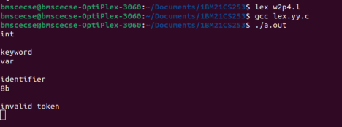

5. Write a lex program to identify a) identifiers

b) keyword-int and float

c) anything else as invalid tokens

Read these from a text file.

%{

#include<stdio.h>

char fname[25];

%}

alpha[a-zA-Z]

digit[0-9]

%%

(float|int) {printf("\nkeyword");}

{alpha}({digit}|{alpha})\* {printf("\nidentifier");}

{digit}({digit}|{alpha})\* {printf("\ninvalid token");}

%%

int yywrap()

{

}

int main()

{

printf("enter filename");

scanf("%s",fname);

yyin=fopen(fname,"r");

yylex();

return 0;

fclose(yyin);

}

OUTPUT

